**Question 1**

Create a webpage containing an image and three buttons

A. On click of the second button a change the existing image to a new image

B. On click of the third button change it once again

C. On click of first, the first image should come back

<html>

<script>

    function img1()

    {

        document.getElementById('theImage').src="win 7.png";

    }

    function img2()

    {

        document.getElementById('theImage').src='win 8.jpg';

    }

    function img3()

    {

        document.getElementById('theImage').src='win 10.jpg';

    }

</script>

<body>

<img id="theImage" src="win 7.png" height="200" width="=200">

<p><input type="button" id="btn1" value="click me!" onclick="img1()"></p>

<p><input type="button" id="btn2" value="click me!" onclick="img2()"></p>

<p><input type="button" id="btn3" value="click me!" onclick="img3()"></p>

</body>

</html>

**Question 2**

Create a webpage containing two input fields and a button.

A. Write something in the first input

B. On click of the button, the content of input one should be copied in the second input

<script>

    function sync()

    {

      var n1 = document.getElementById('n1');

      var n2 = document.getElementById('n2');

      n2.value = n1.value;

    }

</script>

    <input type="text" name="n1" id="n1"/>

    <input type="text" name="n2" id="n2"/>

    <input type="button" name="btn" onclick="sync()" value="Copy!!"/>

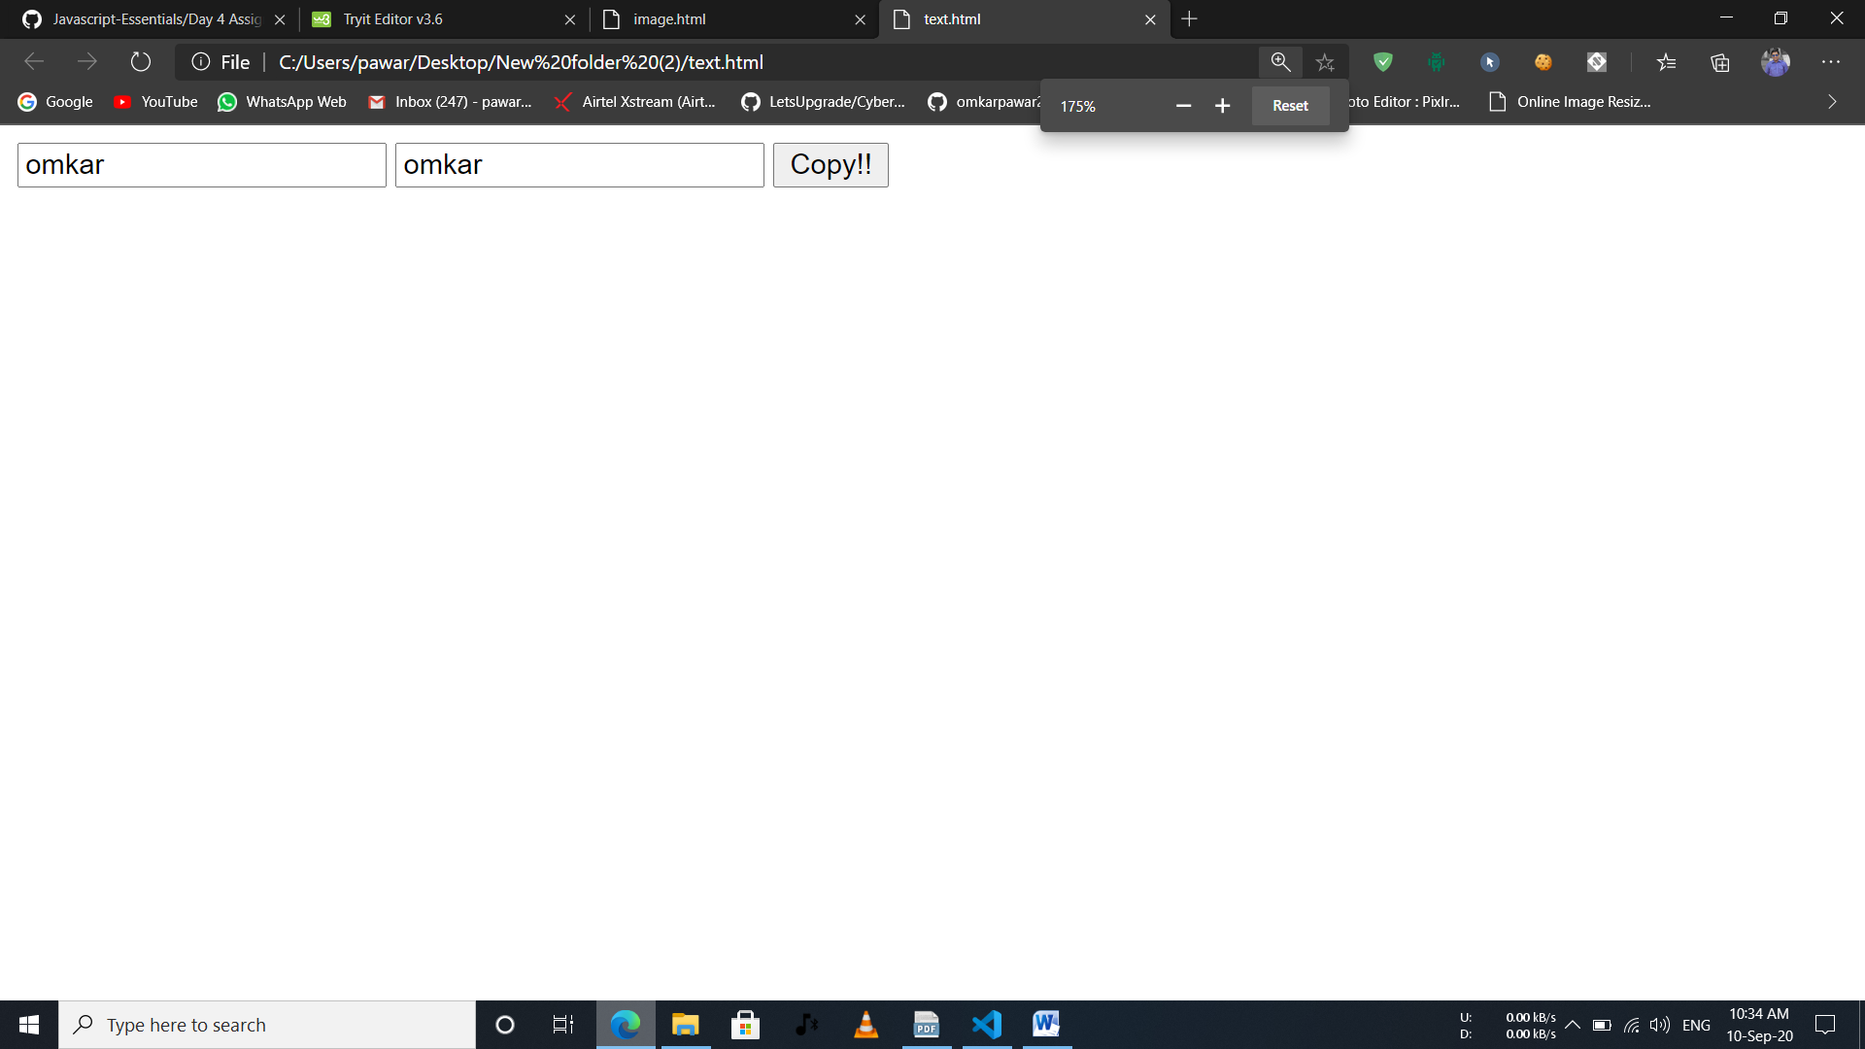

**Question 3**

Create an array of objects with objects having the following properties

A. {name (string), age (number), country (string), hobbies array (string [ ] ) }

B. Write a function to display all the objects on the console

<html>

<head>

    <script>

        let students =

            [

                {

                    name: 'Omkar',

                    age: 19,

                    hobbies: ['gaming','swimming','coding']

                },

                {

                    name: 'Kshitij',

                    age: 19,

                    hobbies: ['dancing','swimming','coding']

                }

            ]

        console.log(students);

    </script>

</head>

<body>Check console for details!!</body>

</html>

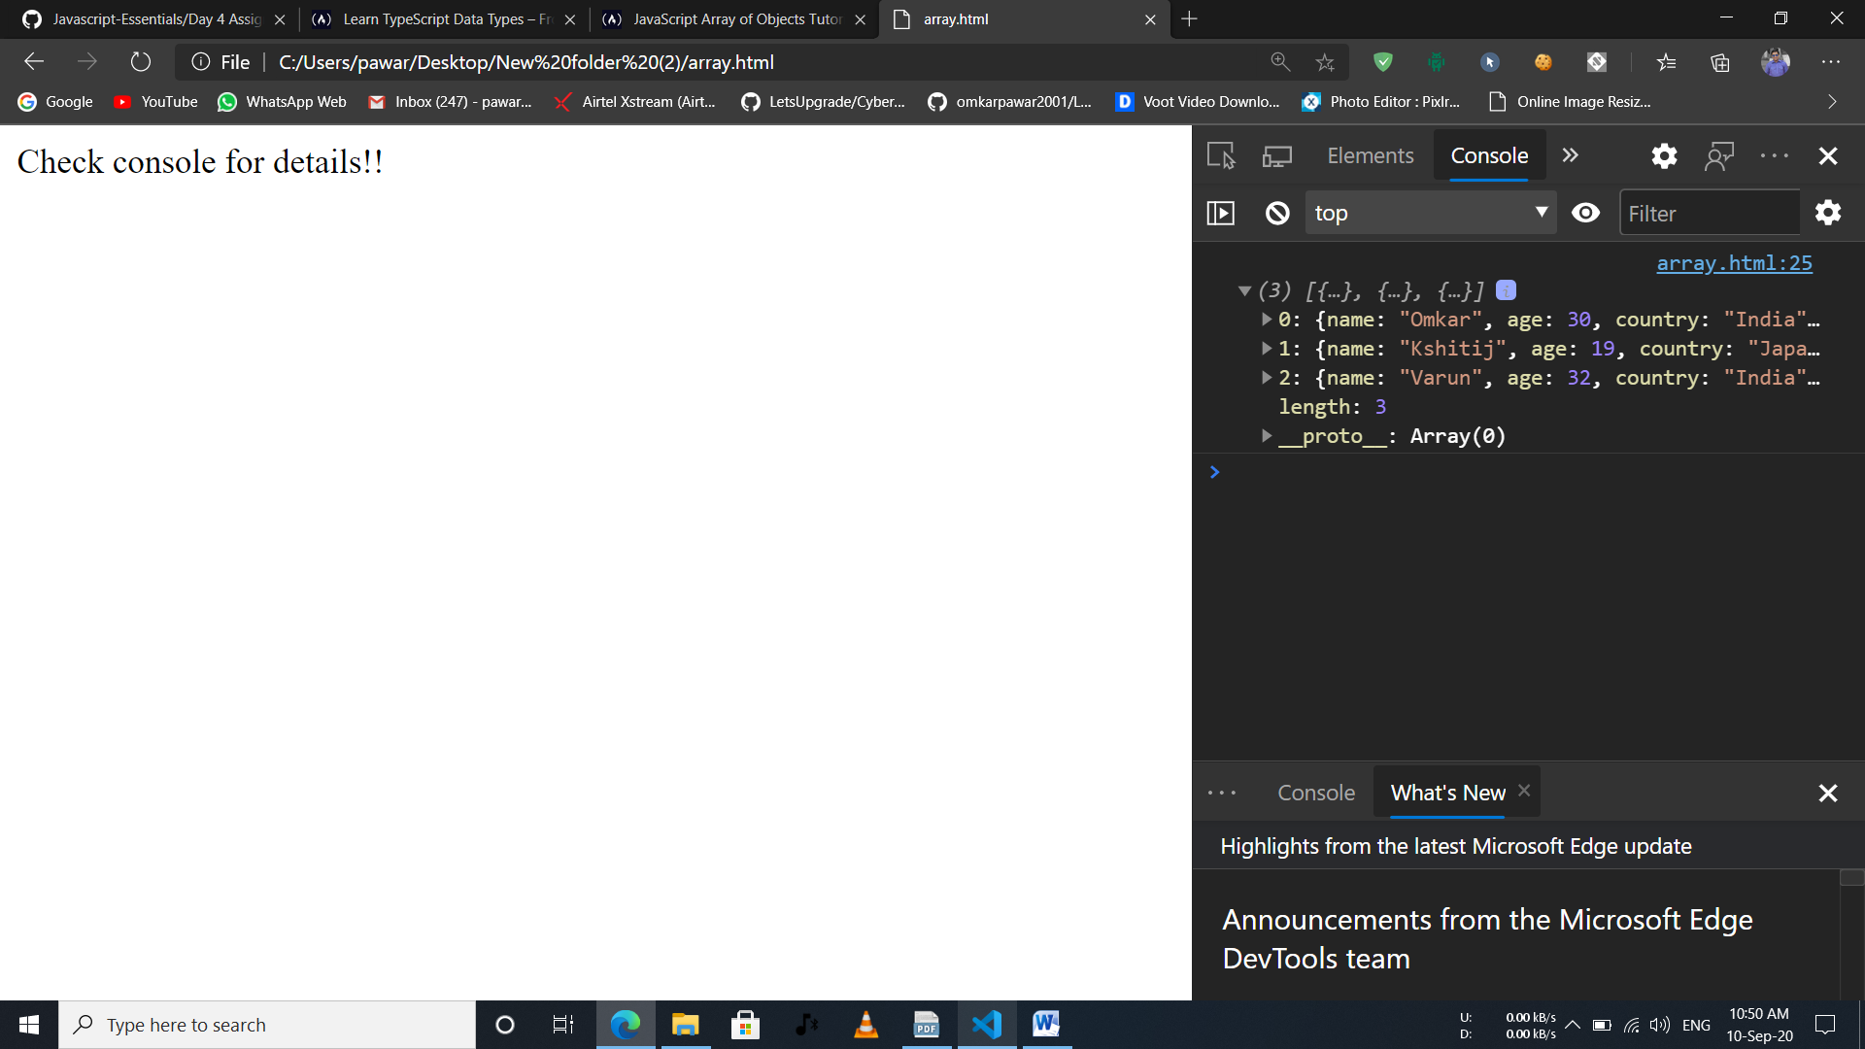

**Question 4**

Following the 3rd question

A. Write a function to display all the objects having age less than 30

B. Write a function to display all the objects having country India

<html>

<head>

    <script>

        let students =

            [

                {

                    name: 'Omkar',

                    age: 19,

                    country: 'India',

                    hobbies: ['gaming','swimming','coding']

                },

                {

                    name: 'Kshitij',

                    age: 32,

                    country: 'Japan',

                    hobbies: ['dancing','swimming','coding']

                },

                {

                    name: 'Varun',

                    age: 18,

                    country: 'India',

                    hobbies: ['dancing','acting','coding']

                }

            ]

        console.log(students);

        console.log("Age less than 30");

        let someUsers = students.filter(item => item.age < 30);

        console.log(someUsers);

        console.log("Conutry India");

        let someUsers1 = students.filter(item => item.country =="India");

        console.log(someUsers1);

    </script>

</head>

<body>Check console for details!!</body>

</html>

